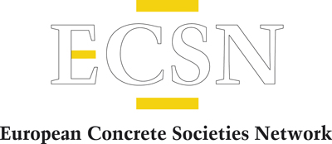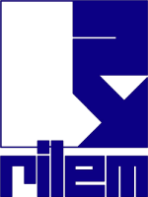

Free webinar: All about RILEM: an international partnership on materials, building systems and structures

Our concrete association is a member of the European Concrete Societies Network (ECSN), which has a partnership agreement with RILEM, an international association for materials, building systems and structures. RILEM would now like to invite you to a free webinar on May 10 (1 hour) to tell you about RILEM and show you the free benefits that you can enjoy thanks to the partnership agreement between the two organizations.
This event is a unique opportunity to present RILEM, an ECSN partner since February 2023. RILEM is a non-profit association whose mission is to create and disseminate scientific and technical knowledge in the field of materials, building systems and structures, fostering links between experts from around the world.
If you would like to find out more about RILEM and its various technical committees, don't miss the opportunity to register for this webinar by following this link. The webinar will be held in English and there will be no registration fee for participants.
The webinar will be presented by Dr Daniela Ciancio (RILEM Implementation Manager) and moderated by Richard McCarthy, ECSN Chairman.

